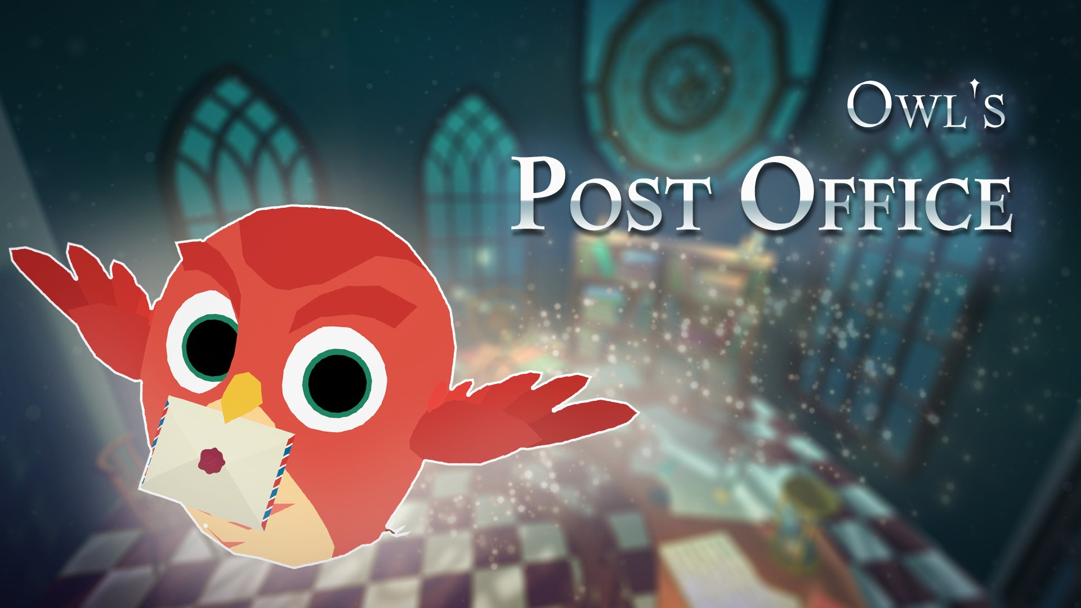

Owl's Post Office

# Cute owls deliver your letter.

## You can easily create games with cute and lovely characters and environment assets.

-6 owl characters with animation.

-Environment assets.

-Demo scene included.

-Useful bezier spline script.

-Works in Unity 2020.3.12f and above

-Video : https://youtu.be/utxAbU3Xyyc

## ++

Before running the demo scene, please import <TouchScript> asset .

<TouchScript> asset

*https://assetstore.unity.com/packages/tools/input-management/touchscript-7394*

# +Source of Curves and Splines scripts.

https://catlikecoding.com/unity/tutorials/curves-and-splines/

↑↑Check the link for a <Curves and Splines> scripts tutorial.

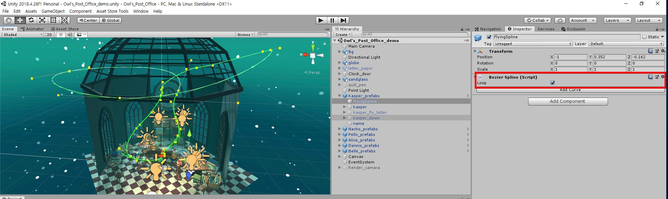

<Script>

8 Scripts file and 4 Editor file.

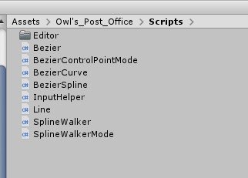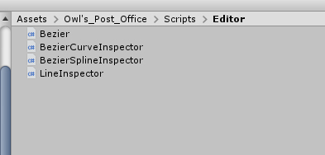

<Scenes>

1 Demo Scene file.

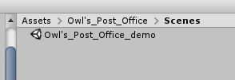

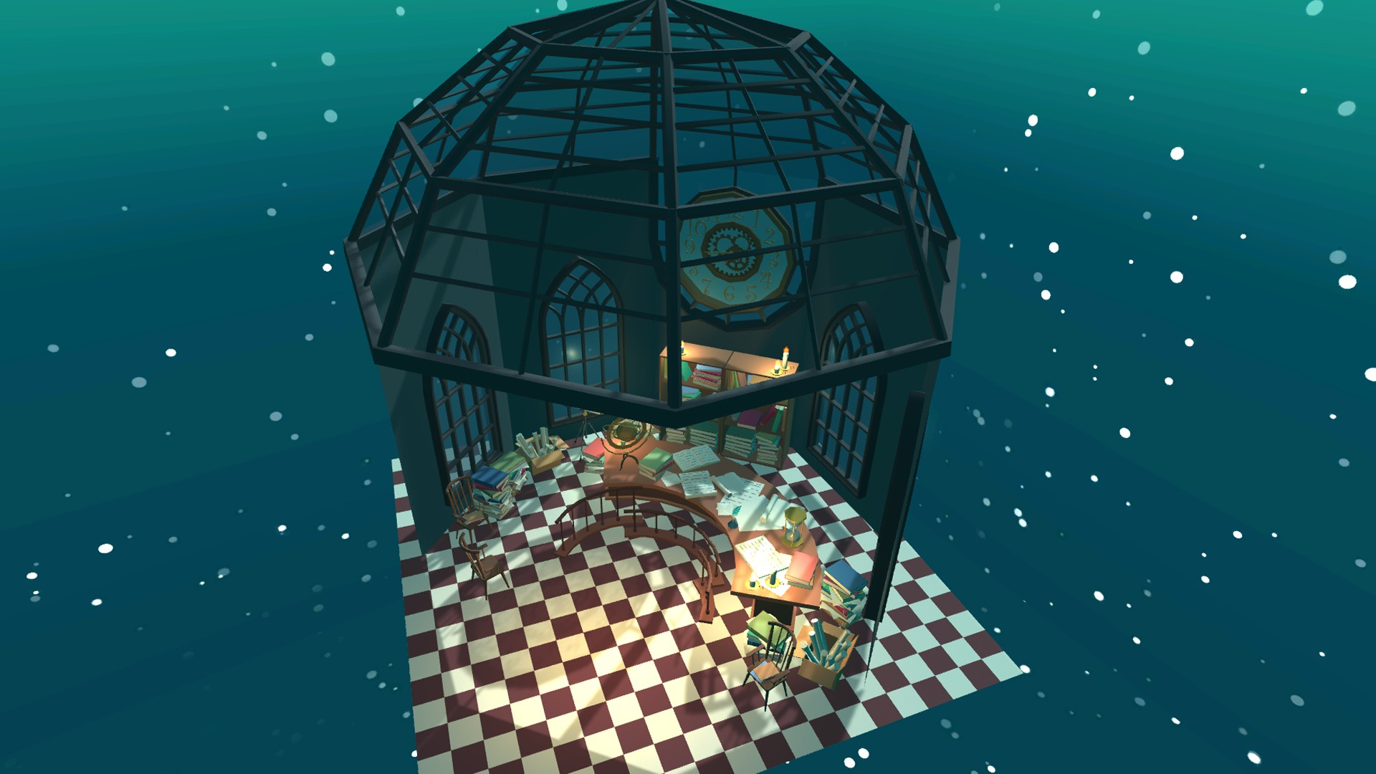

<Environment assets.>

Bg.FBX (Polygon:63,859 / Verts:192,486 / Tris:64,768) clock.FBX (Polygon:7,080 / Verts:21,240 / Tris:7,080) globe.FBX (Polygon:2,244 / Verts:6,844 / Tris:2,356) sandglass.FBX (Polygon:788 / Verts:2,592 / Tris:1,016) letter_paper.FBX (Polygon: 235 / Verts: 641 / Tris : 709)

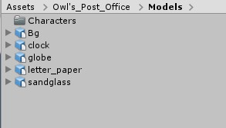

letter_paper.FBX

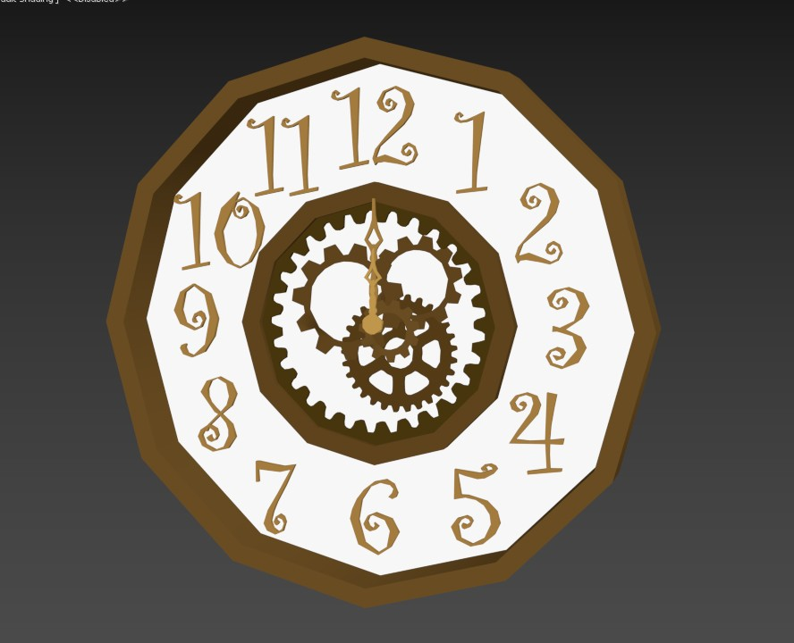

Polygon: 235 / Verts: 641 / Tris : 709

clock.FBX

Polygon: 1,865 / Verts: 3,556 / Tris : 7,070

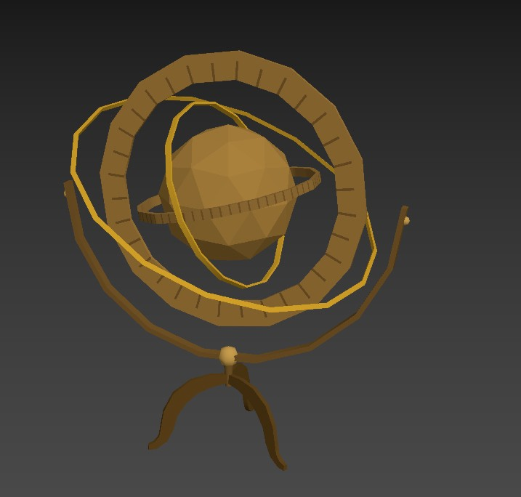globe.FBX

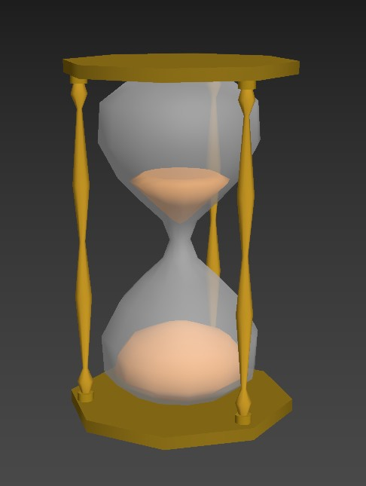Polygon: 1,146 / Verts: 1,196 / Tris : 2,356

sandglass.FBX

Polygon: 518 / Verts: 536 / Tris : 1,016

Bg.FBX ( all-Polygon:63,859 / Verts:192,486 / Tris:64,768)

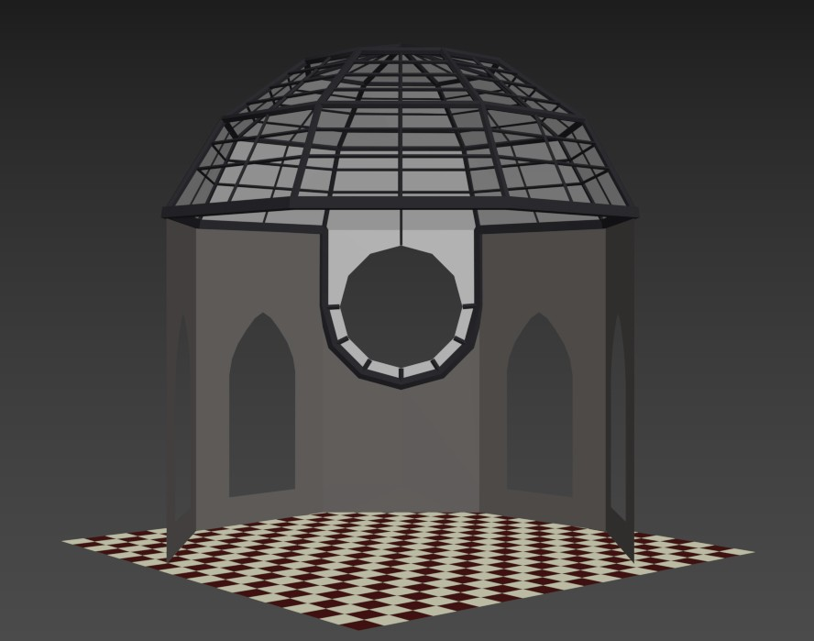room (×1)

Polygon: 2,246/ Verts: 1,293 /Tris : 2,308

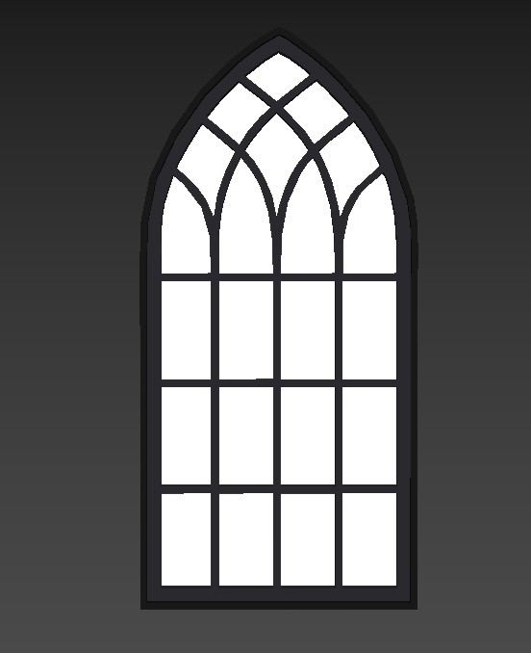window (×4)

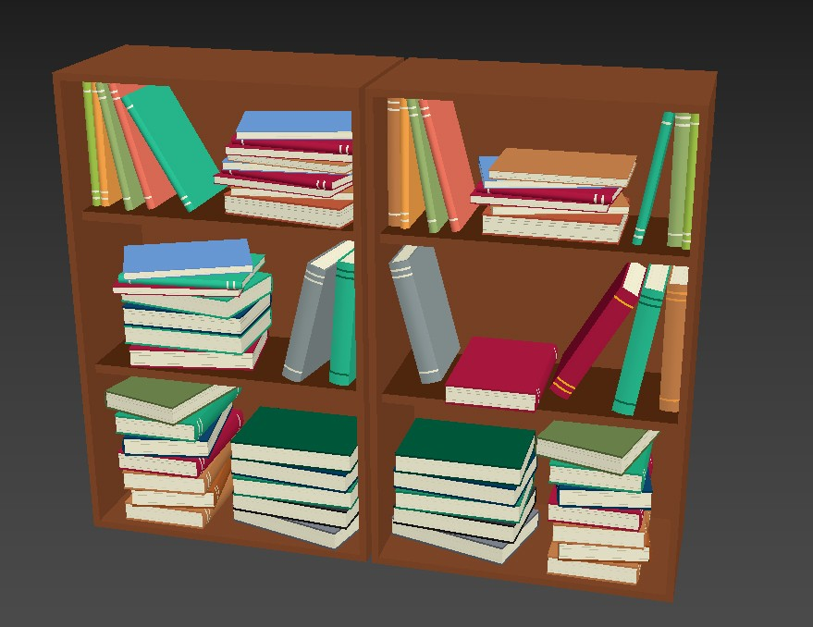Polygon: 1,181 / Verts: 574 / Tris : 1,204

bookcase_group (×2)

Polygon: 4,472 / Verts: 5,524 / Tris : 10,764

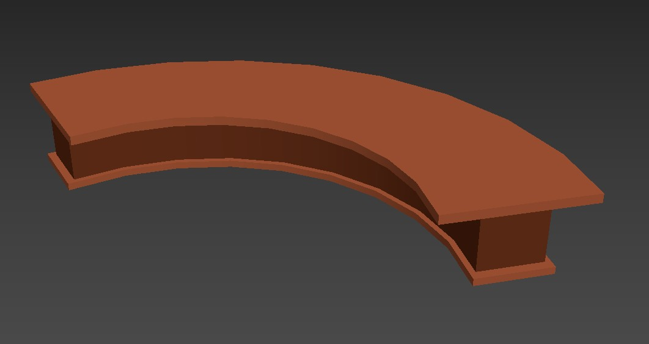desk (×1)

Polygon: 116 / Verts: 120 / Tris : 228

bird_stand (×3)

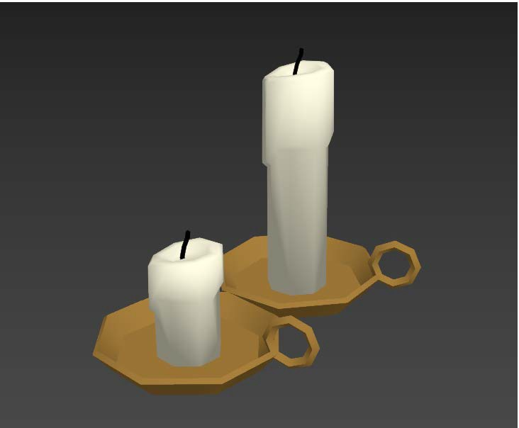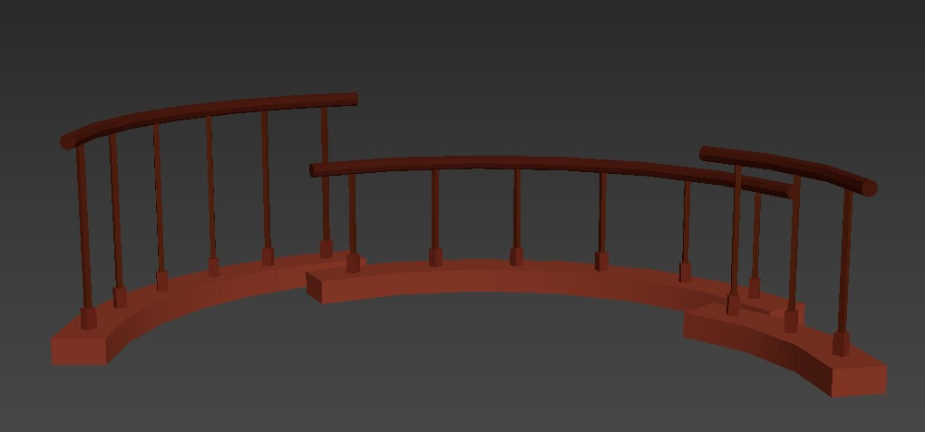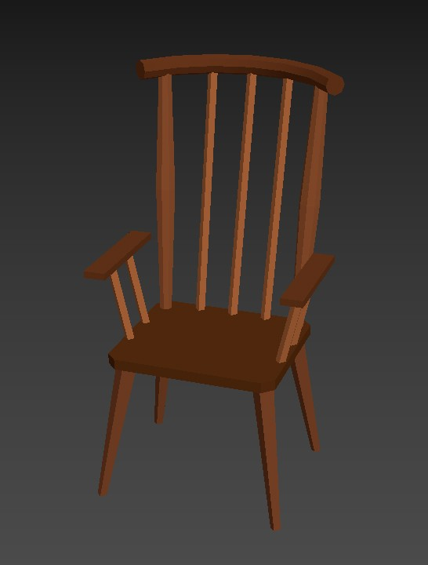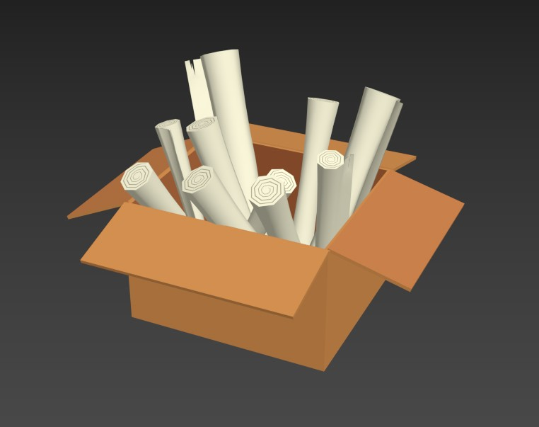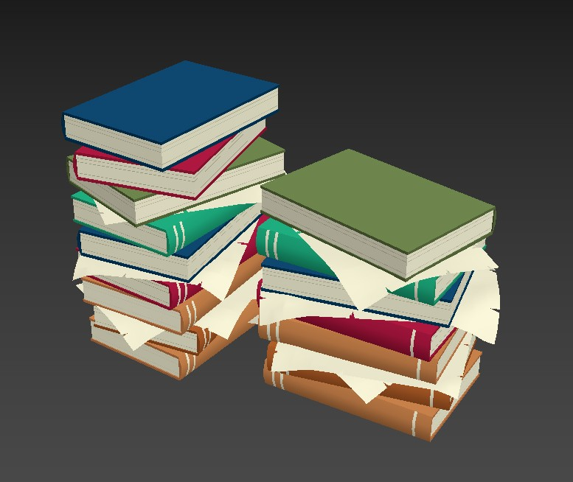

Polygon: 381 / Verts: 456 / Tris : 768

chair (×3)

Polygon: 178 / Verts: 224 / Tris : 380

candle (×7)

Polygon: 135 / Verts: 145 / Tris : 278

paper_box (×2)

Polygon: 2,206 / Verts: 2,280 / Tris : 4,276

book_group (×5)

Polygon: 1,700 / Verts: 2,188 / Tris : 4,028

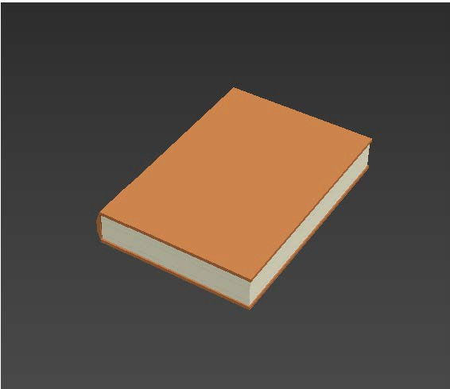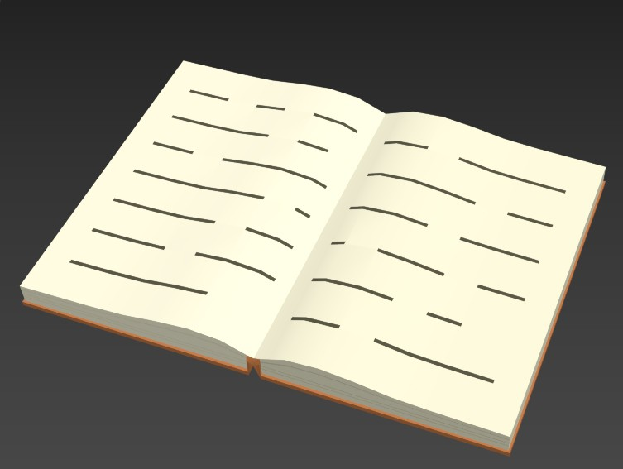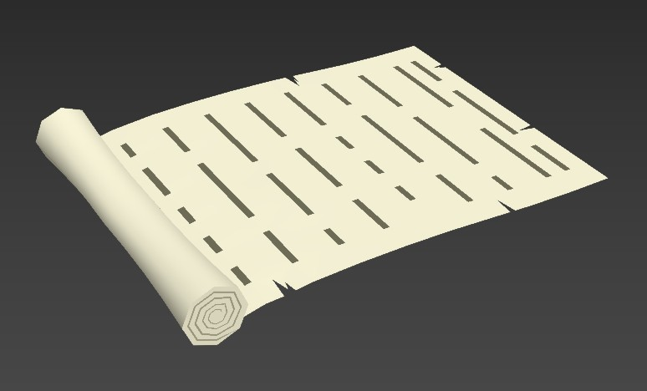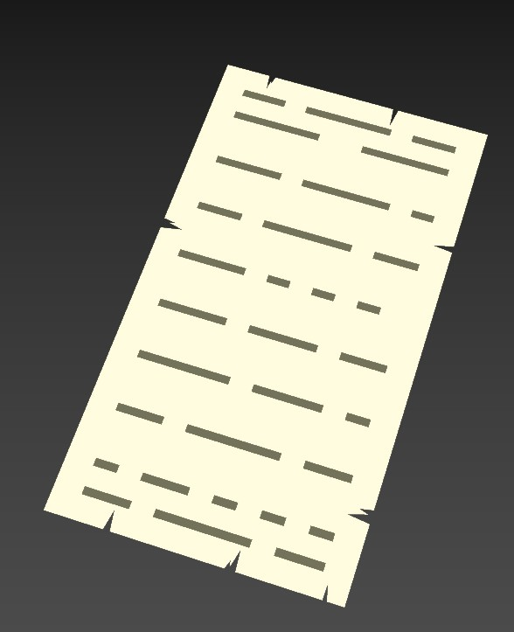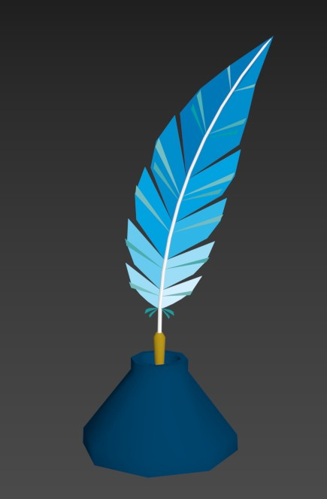

book (×11)

Polygon: 68 / Verts: 84 / Tris : 164

open_book (×2)

Polygon: 346 / Verts: 444 / Tris : 884

roll_paper (×4)

Polygon: 476 / Verts: 554 / Tris : 1,026

paper (×5)

Polygon: 272 / Verts: 358 / Tris : 638

ink_bottle (×1)

Polygon: 265 / Verts: 419 / Tris : 508

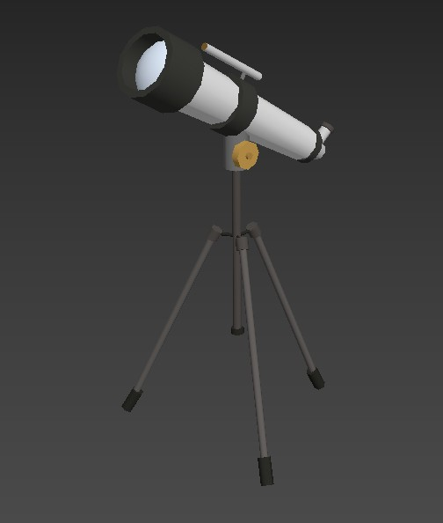telescope (×1)

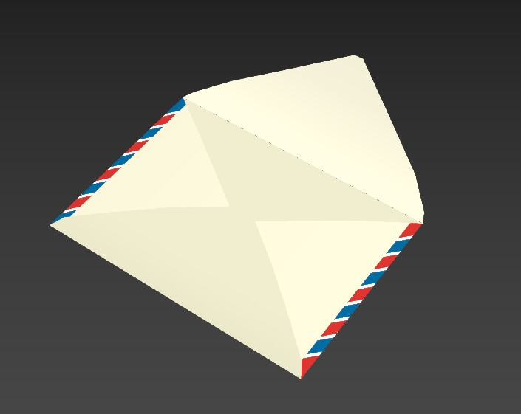Polygon: 298 / Verts: 433 / Tris : 748

envelope (×2)

Polygon: 62 / Verts: 118 / Tris : 138

<Characters>

6 Characters FBX files. (with animation)

kasper/alice/dennis/nach/belle/pello

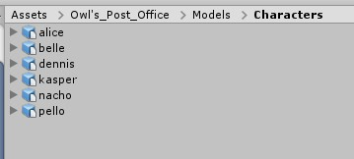

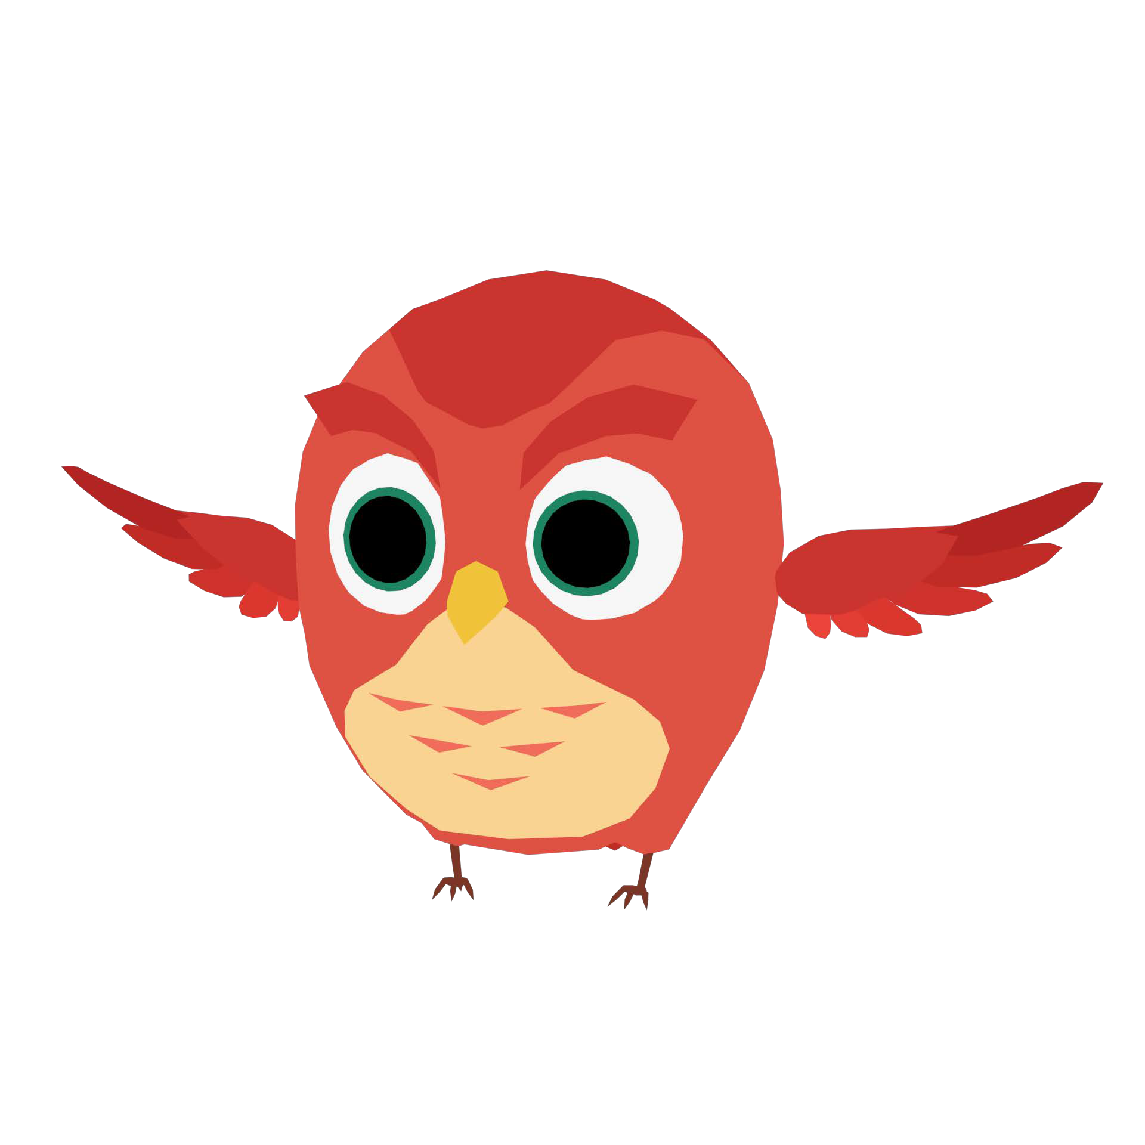 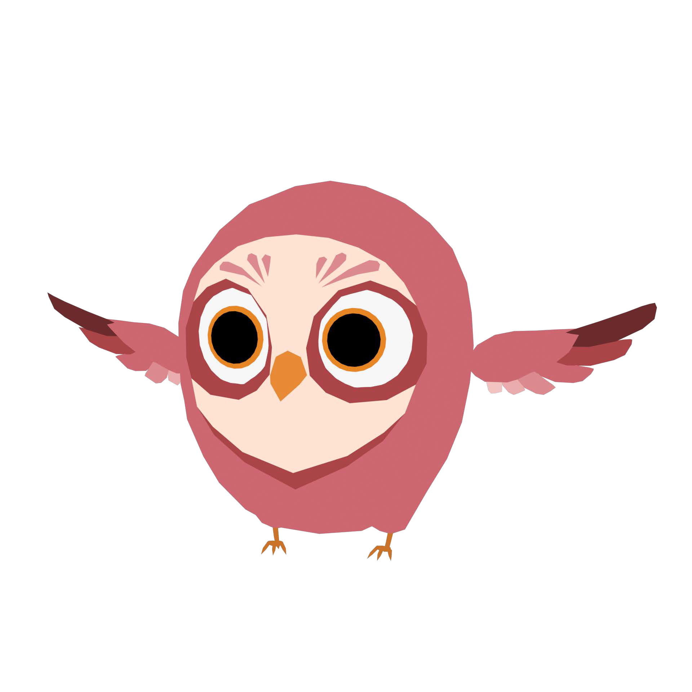 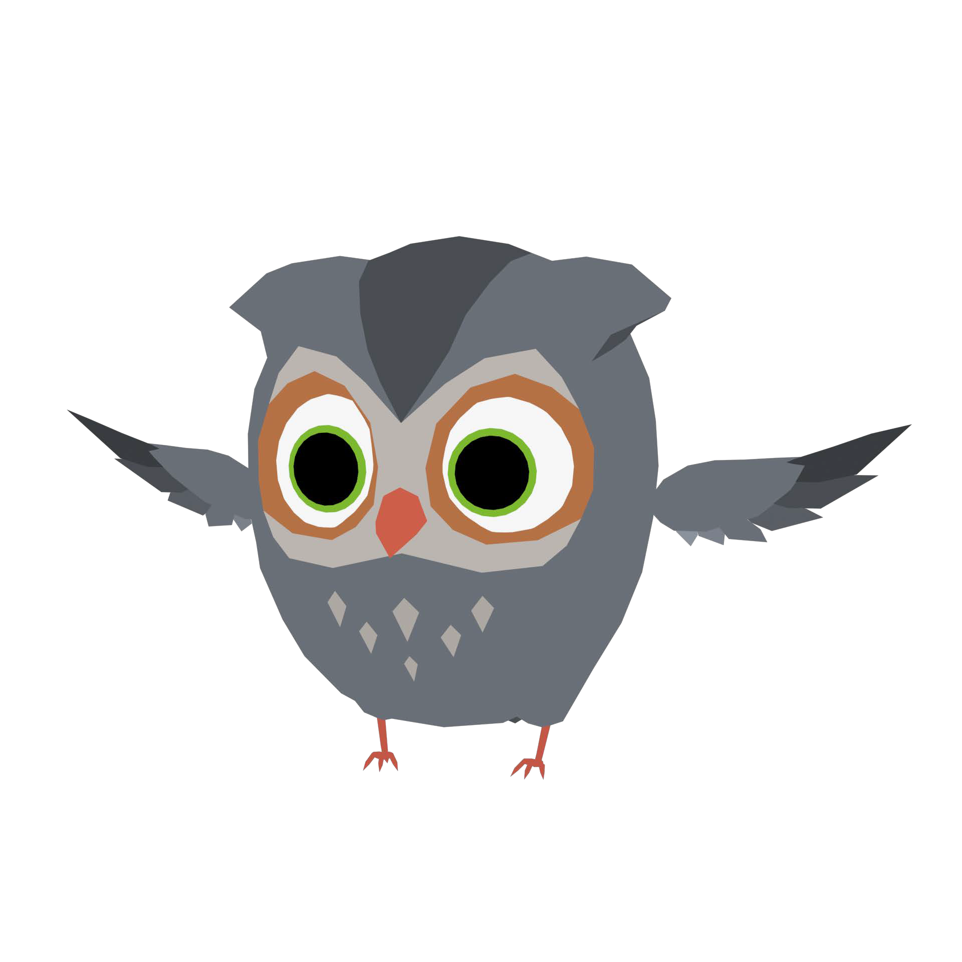

kasper.FBX

Polygon: 2,258 /

Verts: 2,369 /

Tris : 4,233

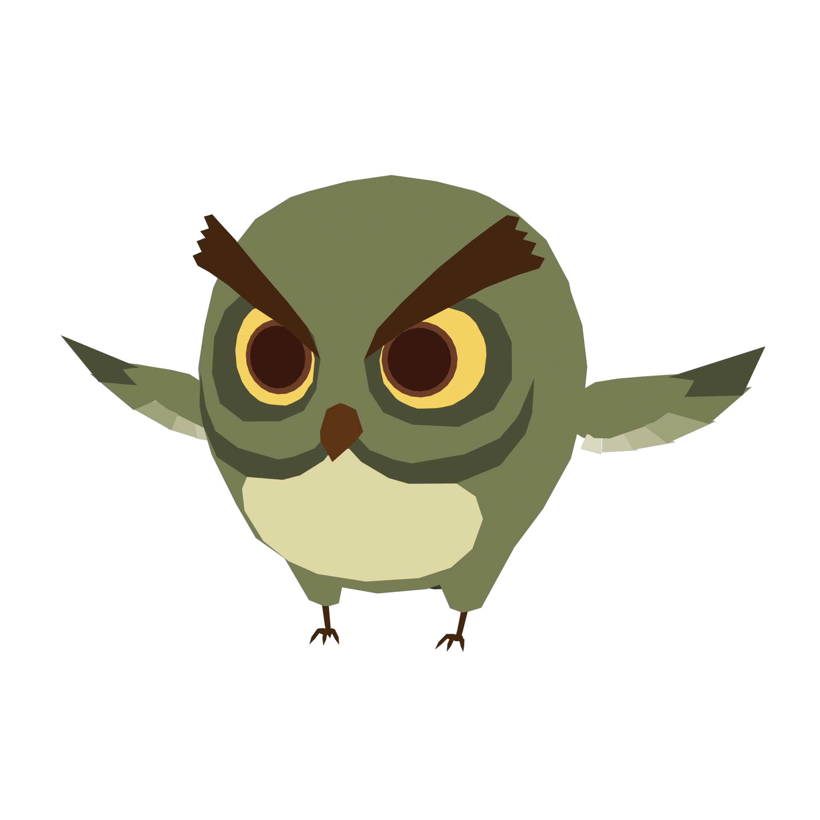

nacho.FBX

Polygon: 2,005 /

Verts: 2,144 /

Tris : 3,751

alice.FBX

Polygon: 2,024 /

Verts: 1,919 /

Tris : 3,684

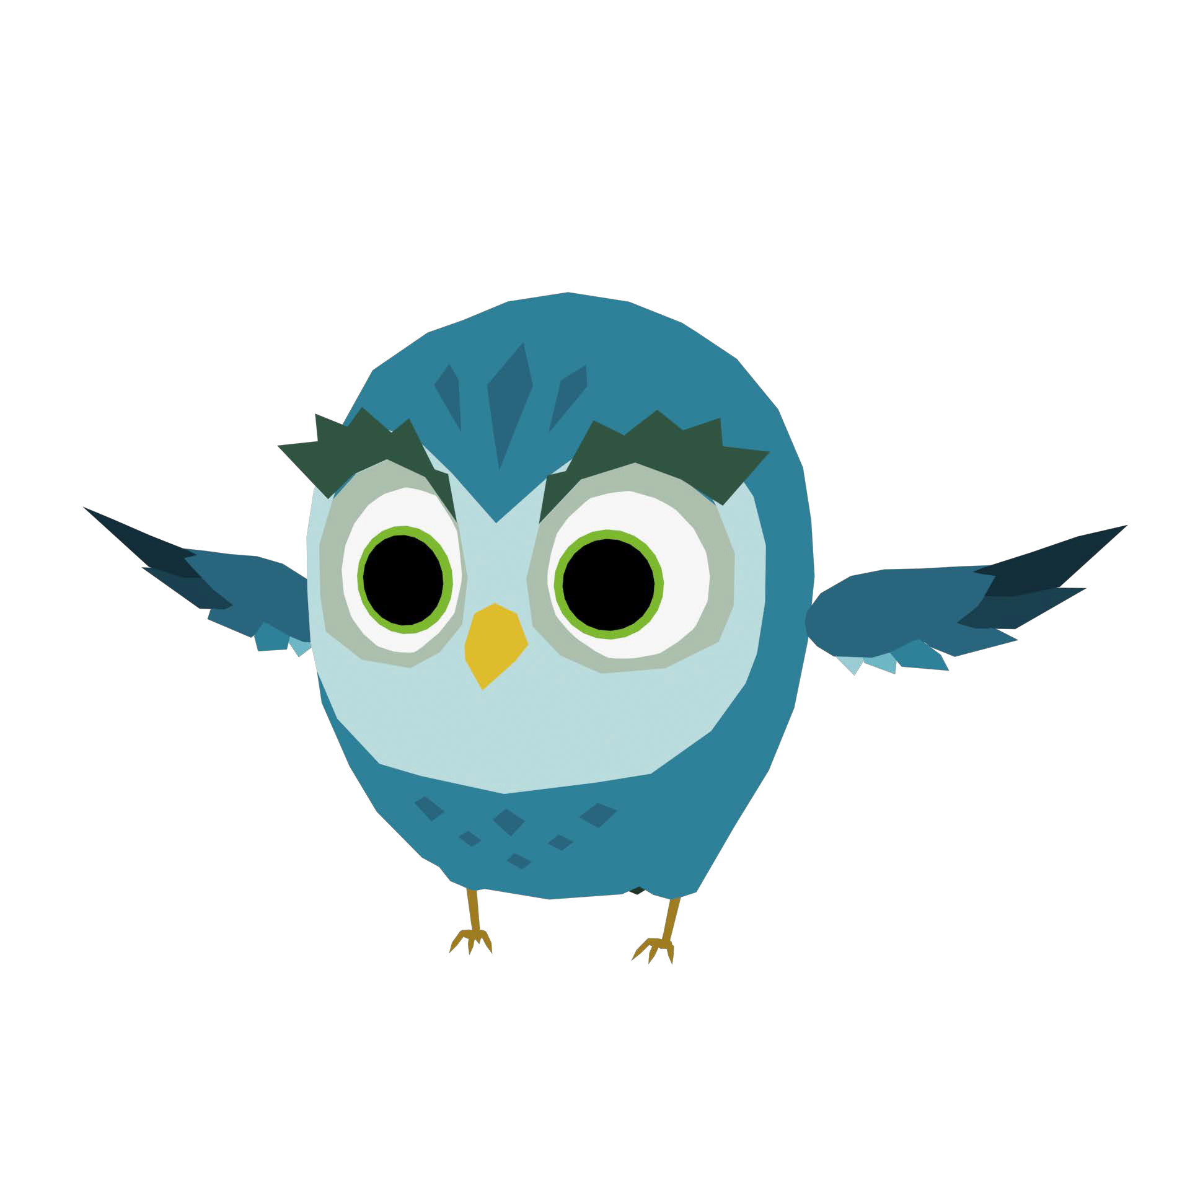

belle.FBX

Polygon: 2,117 /

Verts: 2,264 /

Tris : 4,015

dennis.FBX

Polygon: 2,135 /

Verts: 2,263 /

Tris : 4,043

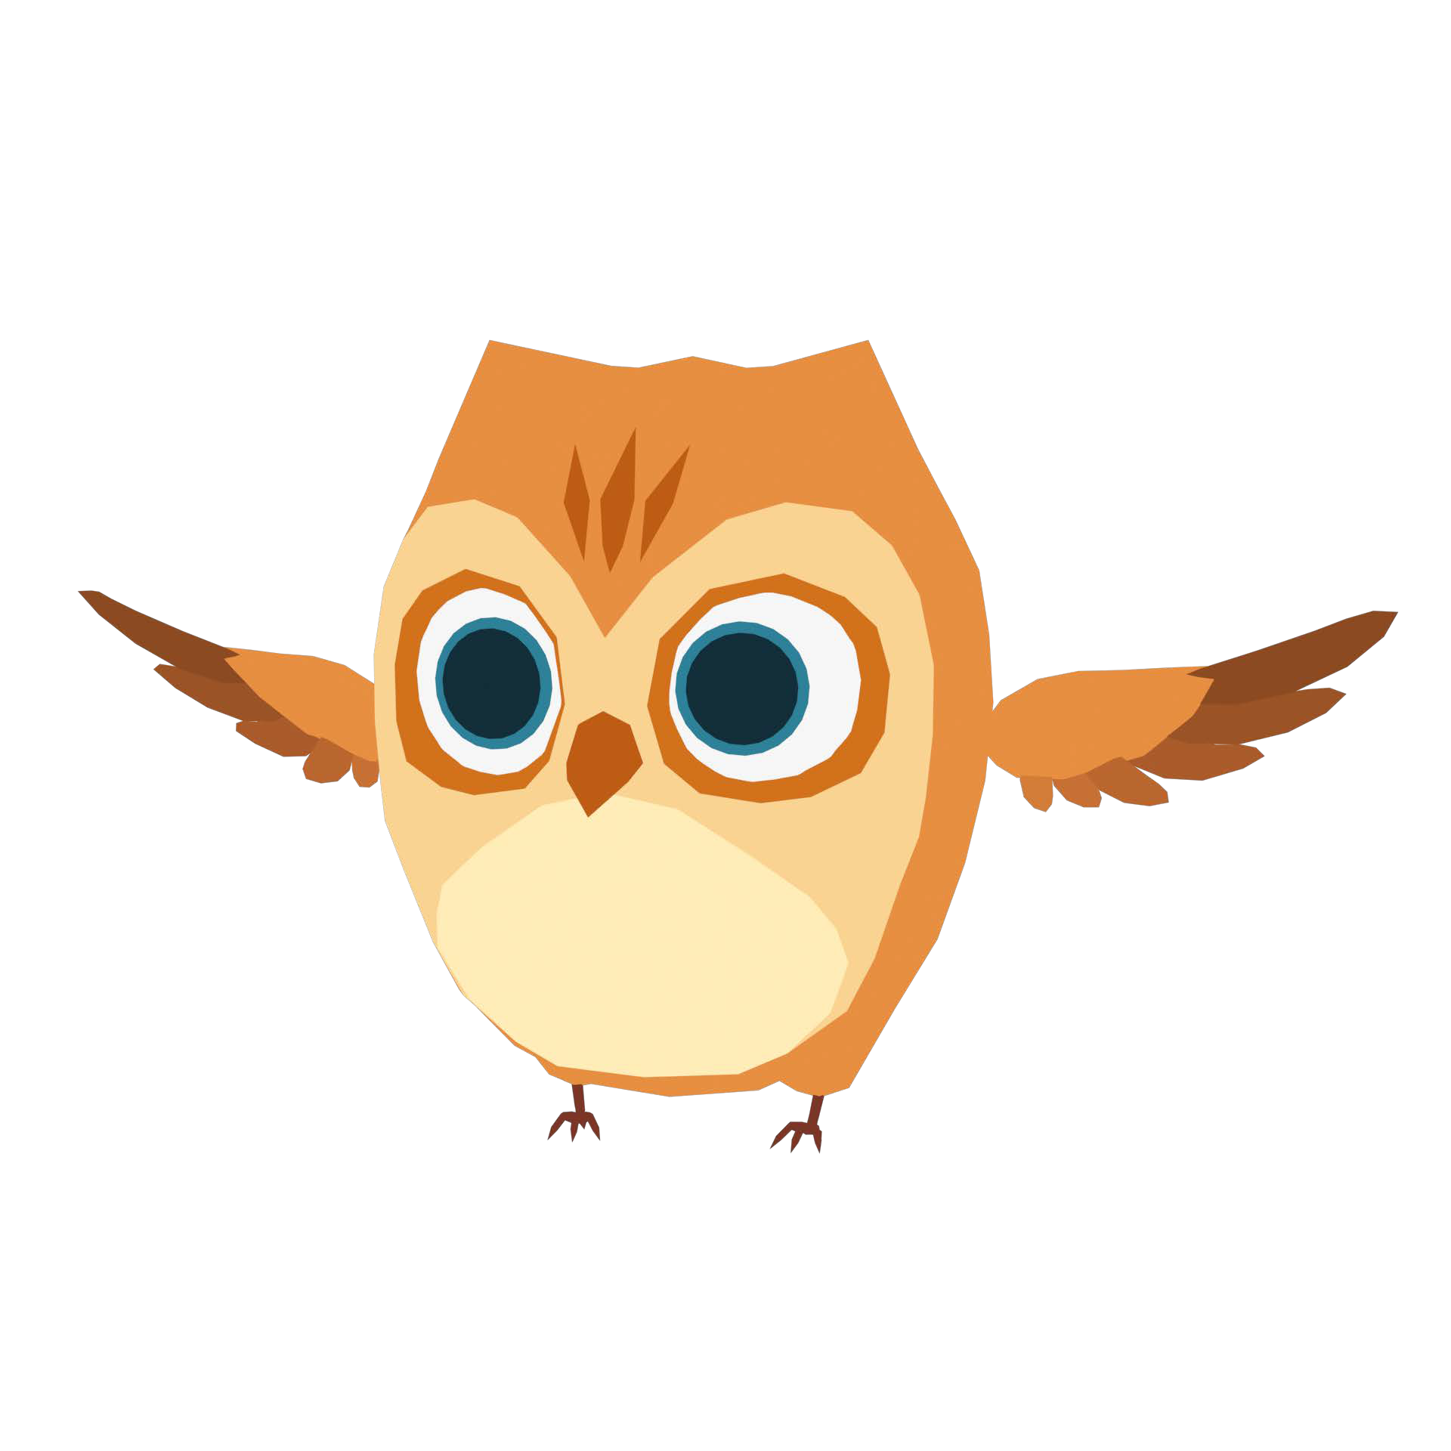

pello.FBX

Polygon: 2,180 /

Verts: 2,325 /

Tris : 4,169

<Texture>

2 PSD files and 11 PNG files.

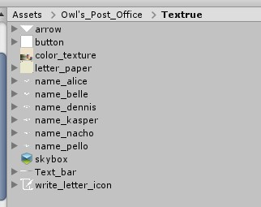

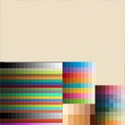

color_texture.PSD Size : 1024*1024

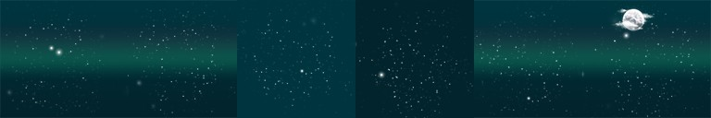

skybox.psd

Size : 12288*2048